

3 year budget plan

Variance Analysis

Forecasting

Budgeting

Stretch Budgeting

Interactive visualizations



FINISH WORKS FININCIAL ANALYSIS

* Ambar Singh
* Arshpreet Randhawa
* Ernest Ulom
* Prathamesh Dhapodkar

May 14, 2019

Finish works limited

Denver

**TABLE OF CONTENTS**

**Part I: Summary……………………………………………………………………………... 2-4**

1. Revenue Generated by Region
2. Revenue Generated by Product Category
3. Risks and Challenges

**Part II: Budget and Stretch Budget…………………………………………………. 5-9**

1. Stretch Budget for Books
2. Stretch Budget for Electronics
3. Stretch Budget for Movies
4. Stretch Budget for Music

**Part III: Variance Analysis………………………………………………………………. 10-11**

1. Variance Analysis for Books- Low Performing Category
2. Variance Analysis for Electronics- High Performing Category

**Part IV: Forecast…………………………………………………………………………….12-13**

1. Key Findings
2. Trendline graph

**Part V: Reports and Dashboards……………………………………………………14-17**

1. Product Performance Report
2. Regional Performance Report
3. Customer Analysis Report
4. Product and Regional Analysis Dashboard
5. Customer Analysis Dashboard

**Part VI: Single Visualization for iPad Screen…………………………………….18**

1. Cashflow Chart

**Executive Summary**

**3 Year Budget Plan for Finish Works Company**

**Part I: Summary**

This report delivers the analysis and the assessment of the historical and the present data which helped to produce some valuable future decisions to increase the growth of the company. Trend method is used to analyze the performance of the product category and the region for the years from 2020 to 2022 by using the existing data of years 2017-2019. The analyzed data manifested the top and the worst performing categories and the regions.

Below is the detailed description of the analyzed data with graphs and assumptions made based on the analysis.

**Revenue generated by Region:**

According to the above graph it is distinct that the Northeast and the Web played a key role in generating the revenue accompanied by South and the Central. If we have a look on the forecasted revenue of the year 2022 then web is on the top in boosting up the revenue of the company. This tells the e-commerce is the crucial aspect in generating most of the revenue to the organization as these days’ customers are more inclined towards the online shopping. Moreover, if the company target on developing the web region then it would also be beneficial in lessening the maintenance cost and improving the scalability. However, best overall performance in generating the highest revenue is given by the Northeast region.

**Revenue generated by Category:**

As the below graph depicts that electronics is the best performing category in producing most of the revenue followed by the movies. On the other hand, books and the music are the low selling products. The given data elucidate that company is economically performing better in electronics whereas the revenue generated is extremely low in books and music. In respect of the macro environment, the company would have made production processes more efficient in order to decrease the cost of the products would help to increase the sale of the products. Apart from this, they could include the diverse range of products in music and books and discontinue some outdated products for example company could incorporate e-books as customers have more desire to use new technology and the internet. The organization could encourage the people to buy products through web channel because this channel can serve as the competitive advantage to the company.

**Risks and challenges:**

As explained above there are many domains which are at high risk regardless of the increased revenue. The company might have increased the prices of some products on account of that sale of the products has decreased so in that scenario they could keep the prices low to augment the sale of the products. The company is vulnerable to risk when it is reluctant to the change for example when it sticks to the old technology or the products so to avoid that situation they could terminate the sale of the outdated products and include new variety of innovative products with new designs to prompt the people to buy those products. Beside this, association with other channels like e-commerce channel could support the company to achieve the competitive advantage in marketplace.

**Part II: Budget & Stretch Budget**

Our company has seen a burst in growth across all regions in the financial years 2017, 2018 and 2019. Our forecasted data shows even better results in future as this growth is expected to continue for some time. For 2020, the forecasted revenue is $18,377,673.30, for 2021, the forecasted revenue is $22,518,053 and for 2022, the forecasted revenue is $26,525,871. The percentage increase in forecasted revenue from the year 2020 to 2021 is 22.53% and from 2021 to 2022 the forecasted revenue growth percentage is 17.8%. This is a positive sign going forward for the company. Although, the company is doing good across all sectors, even further growth is always a possibility.

Our findings highlight that the Book department generates the smallest share of revenue at 7%. The month to month growth in the book category is the lowest of entire product line up. Music and Movies are also low performing categories which contribute only 11% and 12% of the entire revenue, respectively.

These areas, however, look ripe to generate revenue, considering we also offer electronic products and most of the Books, Music, and Movies are now distributed digitally. It is our recommendation to bundle the products from Books, Music and Movies category with functionally sound electronic equipment. For example, a bundle of Digital mp3 player and a Music title, a HD TV and a set of movies, etc. This will generate extra inflow income added on to the regular one.

We can also remove legacy products and replace them with products which are currently hyped with youth such as Kindle Tablets, eBook readers, Go Pro, action camera, etc. Introducing eBook reader will also allow us to deliver books through digital medium and on the go.

To achieve the three scenarios of revenue growth for Finish Works Company, we can deeply analyze our trends and can regularly conduct post sales analysis and document the findings. With our findings, we can identify our risk and challenge areas in order to take measurable actions to improve in those areas. We firmly believe that these steps would help us to achieve our stretch budget goals.

From the graph above, we can see that the maximum revenue is generated by the Northeast region and if we stretch our budget for same, we can maximize our revenue by $207,670 for the year 2020 alone.

Though this is the best product category, we can still take actions to improve and reach our stretch budget goal. We can see that the two best performing regions here are Northeast and Web. We can concentrate on the least performing areas which will surely help us to stretch our budget goals.

Movies are the next best performing category. As we can clearly observe from the above graph that Northwest and Southeast are the two regions which need improvement. By improvising our movie selection according to the region we can attain our budget goal, and this will improve the overall revenue growth of the company. We should look to add movies to attract younger audience as they are the one using the latest technologies and have better understanding of it. The homes are now enabled with 1080p and 4K TV sets and the medium of watching movies can shift easily if we target the right audience.

Music is one of the least performing product categories. An overall improvement of this category across all region will help Finish Works Company to stretch its overall budget goal. We are extremely handicapped in this category as we are missing on genres like R&B, K-POP, Metal, etc. We need to sell right music to attain our stretch goal budgets. We advise we make some major additions to the music directory of our organization.

**Part III: Variance Analysis**

For the company to restrict on their budgets and expenditure the variance analysis is needed to limit the expenditure and investments. Variance analysis for products gives the performance of the product, its demand in the market. It is the difference between an expected or budget amount and actual amount. It gives us the explanation for the difference. Variance analysis is usually done between the actual revenue and forecasted revenue so that it can explain the performance of the product in the market.

**graph: var1**

The above graph gives us the variance analysis of the regions over the performing years for the worse performing category which is books. It tells us that which region is the best and worse in terms of revenue generated by the books. Over the years we can observe that Northeast region is the best in terms of revenue generated by books. After that the second-best region that was predicted was south region where the forecast for revenue was high. But we see the growing trend of online retailing or e- commerce so to speak, which generates the second highest revenue.

This tells us that the web has shown the highest percent of growth over the years. We can predict that the overall revenue from the web region from the future perspective could increase the revenue amount compared to the northeast region. As we observe it in the trend graph during the forecasting.

We also see the low performing region being northwest and southeast regions as they generate lower revenue combined compared to northeast. Focusing more on the regions would help the company increase the revenue from the books in the regions. Investing more in the category or focusing on marketing or promoting more readers could help the category in the regions to perform better.

**graph: var2**

The graph above gives the variance analysis of the best performing category Electronics. We can see that there are some negative variances in the category which implies that the category is not performing as expected in some regions. But over the years we could see that the revenue generated is still more and increasing. The reason here could be the saturation of market for the products that are being sold over the years.

To cope up with the situation one solution could be that discontinuing of some products which are not performing well in the category. The product analysis could fetch us those findings and promoting new line of products that are technologically new and advance which appeal to the age groups. In the reports we can observe the product analysis of age category and what products they prefer over some products. This can help the company in generating better numbers than expected.

Here we can observe that the most high performing region being Northeast and the percentage increase in the web region is significant, which suggests that the web technology and e-commerce is the future and need to focus more on it. The major low performing region is Northwest.

Assuming the weather conditions and population demographics of the country the northeast is more populated, and northwest is less, based on that we can reasonably justify the retail numbers are less in northwest compared to northeast. We see this trend in both analysis for the categories. But similarly there is no data for the web region, so as which region is using web as their platform for e-commerce. This could tell us the performance of the regions more accurately.

Therefor to gain advantage over the competitors the company should focus on gaining in depth data for Web region and invest in the regions which are under performing.

**Part IV: Forecast**

The scope of the forecasts developed for Finish Work Company takes an unconditional approach highlighting revenue over a three-year period (2020-2022) from years 2017 - 2019. The Unconditional forecasting approach indicates what is likely to happen in the future, all things considered together.

Forecasting for year 2020 was derived by applying regression analysis equation on the monthly revenue data of years 2017-2019. Forecasted data for year 2021 and 2022 was derived by applying the regression analysis equation on years 2018-2020.

The following assumptions were made in the preparation of the forecast:

* Considering the volatile political environment, market conditions are likely to slightly shift thus causing inflation. According to data on [Statistica](https://www.statista.com/statistics/244983/projected-inflation-rate-in-the-united-states/), inflation rate is likely to increase 2.13% in 2020, 2.04% in 2021 and 2.07% in 2022.
* There would be slight changes in purchasing behavior of customers partly due to inflation but nothing significant to effect changes in the forecasting model.
* Regional customer demographics are evolving and are expected to evolve further in the future.

**Key Findings**

From our forecast, the major insight was the unprecedented exponential growth rate for the web Chanel from year 2017 to year 2022 as seen in the visualization below. This could be explained by a lesser amount of goods sold but with higher prices as a result of the inflation. Thus, Management would have to consider increasing discounts for high performing categories or bundling products to encourage customers to purchase more.

Across the remaining regions for there seems to be a consistent growth rate for all years across categories even for years 2020 and 2021 where inflation was anticipated at 2.13% and 2.04% respectively.

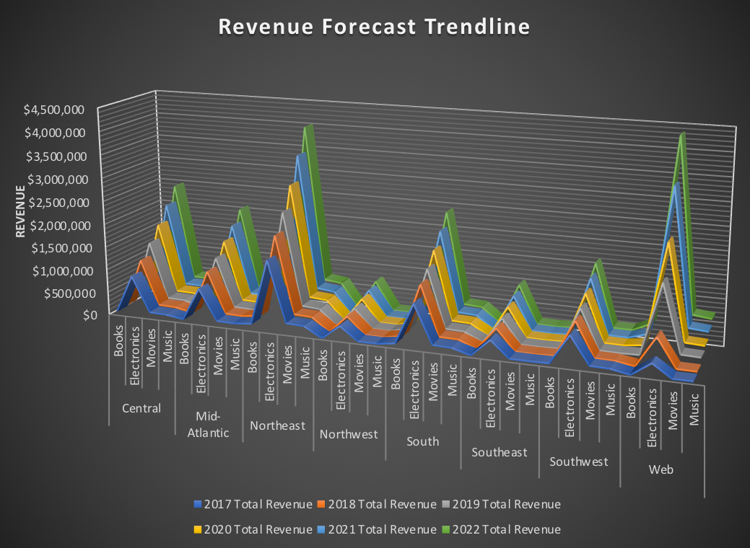

From the forecast, we further analyzed the top and worst performing regions and the chart projects the Northwest region to be the worst performing region across the forecasted years with a total revenue of $2,750,439 while Web was projected to be the best performing with a total revenue of $14,462,541 across forecasted years 2020 – 2022. The trends for the projected revenue are like that of the actual revenue for year 2017-2019.

In addition, we project that the top and worst performing product categories in terms of revenue generation for the forecasted years would be the book category with a total revenue of $7,501,679 while electronics apparently was projected to be the best performing product category with a total of $46,963,621 in revenue. This is not new as the trend of the projected revenue aligns with that of the revenue of the actual years.

**Part V: Reports and Dashboards**

**Product Performance Report:**

The Product Performance Report shows the units sold in each subcategory and the profit made after those sales in the years 2017, 2018 and 2019. This can be used as a guide to eliminate underachieving, least productive, outdated and legacy products. They can be replaced by new generation of products and the hyped products to generate extra revenue to attain our stretch budget goals.

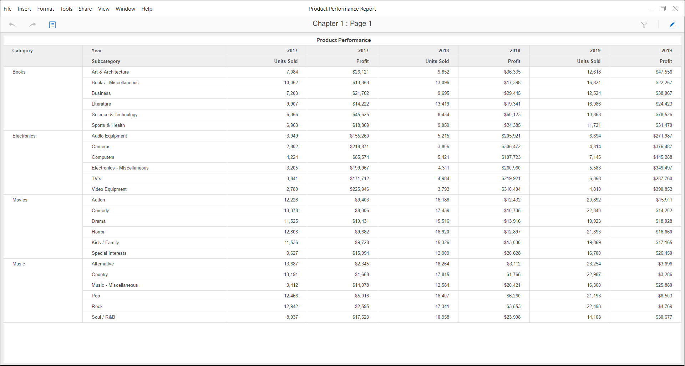

**Regional Performance Report:**

The Regional Performance Report shows the number of customers acquired by each region. It also displays the revenue and profit made by each region individually. This can be utilized to know the best performing and the worst performing regions of the company. Therefore, measured investments in underperforming regions can be made to bump up the performance of sales.

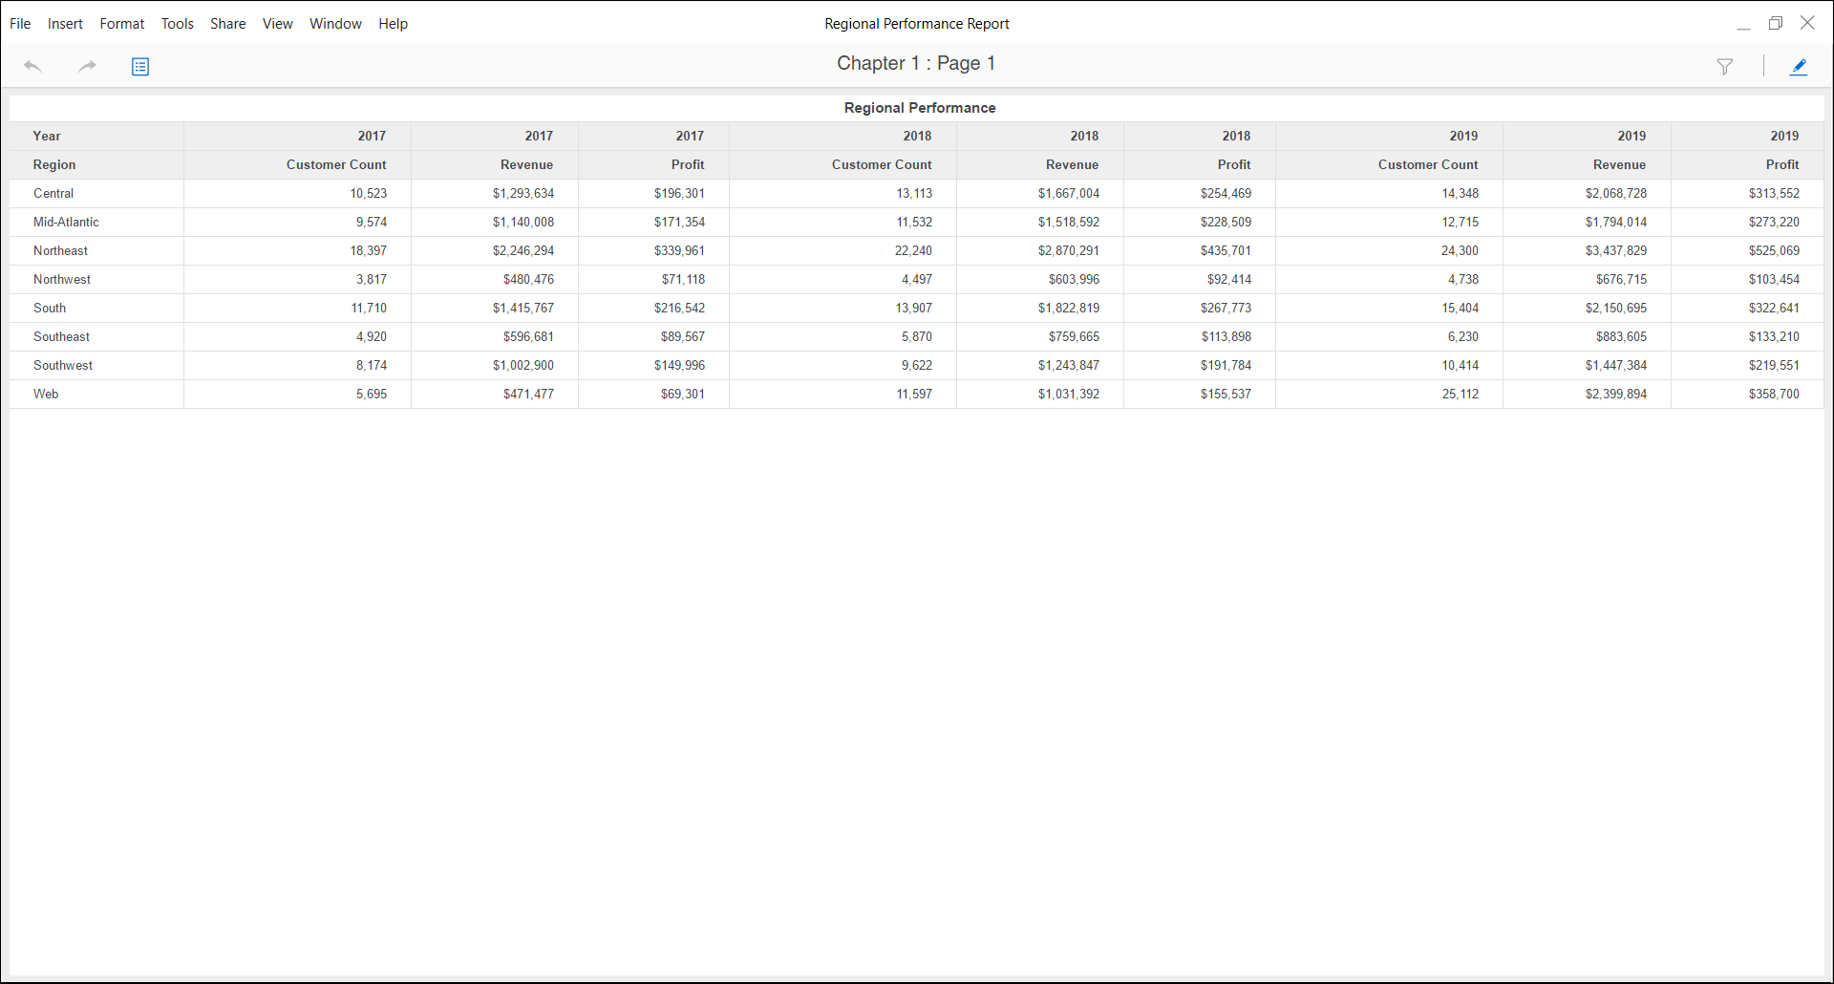

**Customer Analysis Report:**

The report breaks down customers in age groups to analyze the purchase pattern. These categories are further scrutinized based on gender to understand the spending needs. Breaking down by gender also helps us identify the need of selling products specific to a gender to increase sales. Through this report, we can also understand the need to attract younger customers through new products. These products can include new popular genre of music and movies, youth oriented electronic equipment, etc.

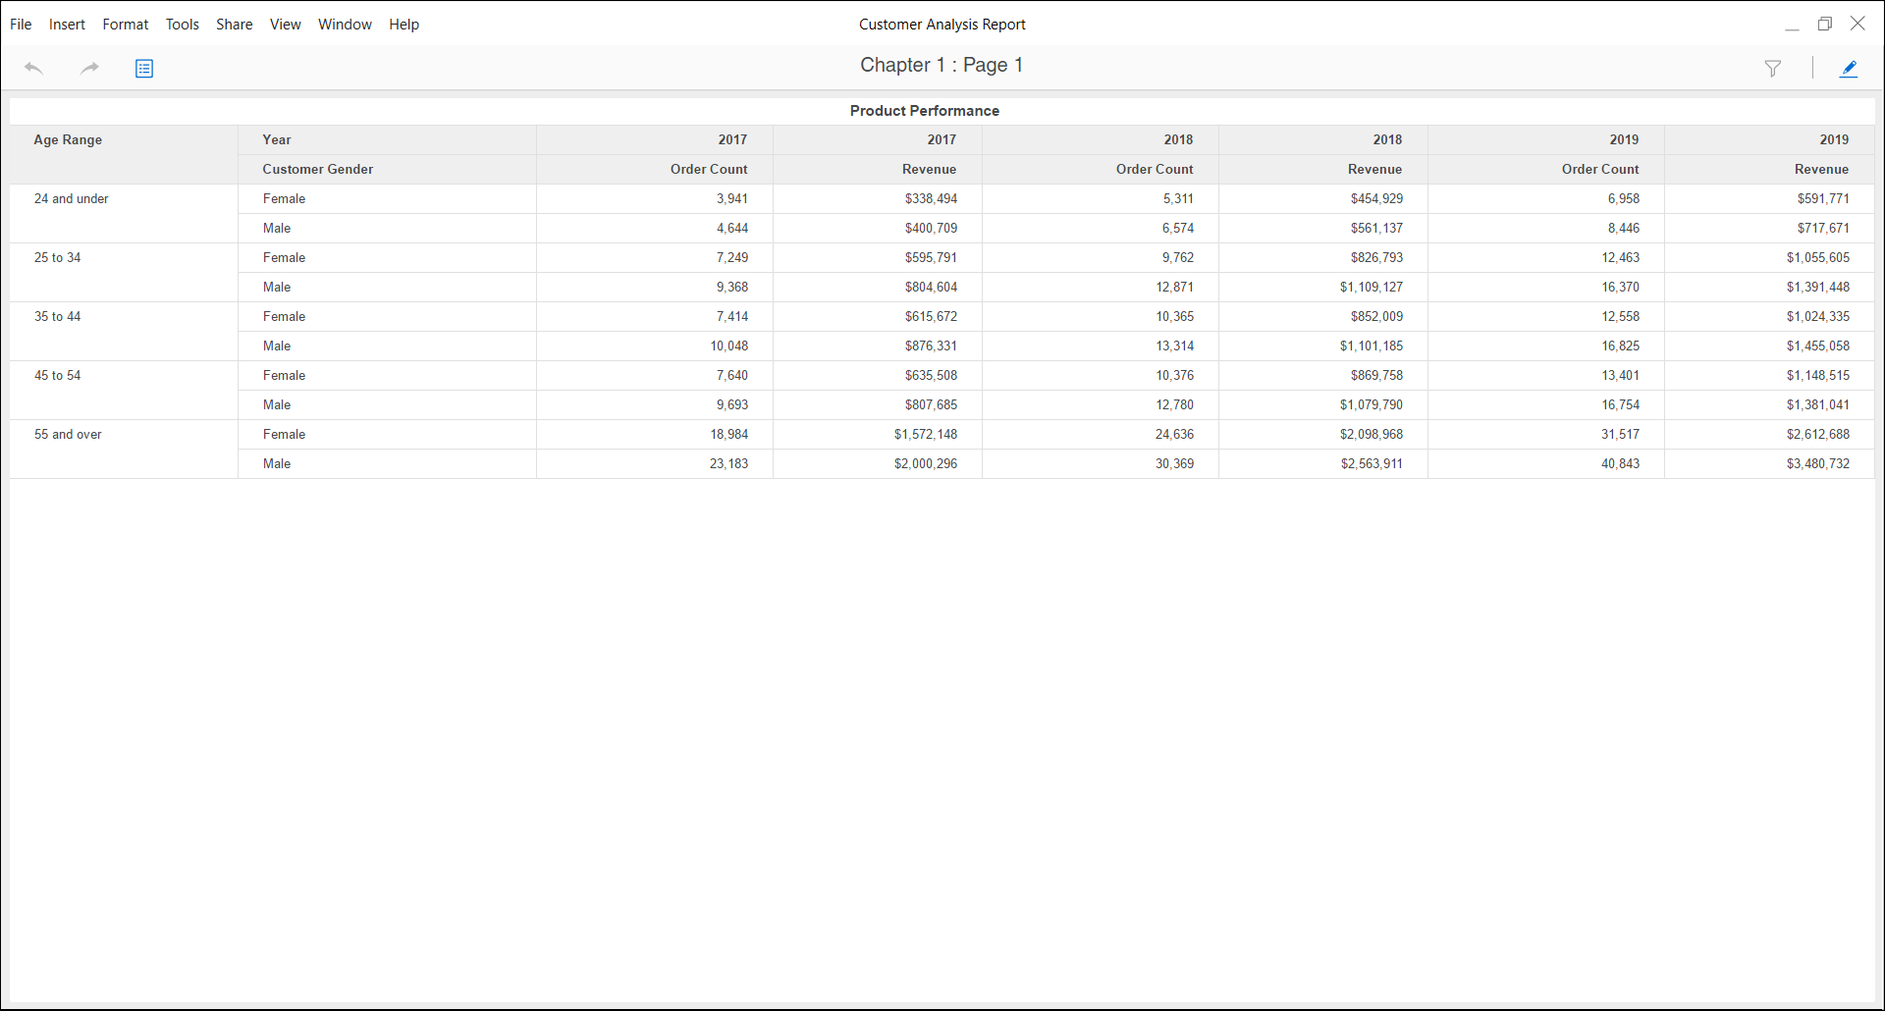

**Product and Regional Analysis Dashboard**

Product and Regional Analysis dashboard delivers the information on company’s revenue health with each passing year. It analyses percentage of units sold by each region, the revenue made by those sales by each product category, profit and revenue relation, and the increasing customer base in each region. These parameters help us understand the growth in customer base which leads to higher number of units sold.

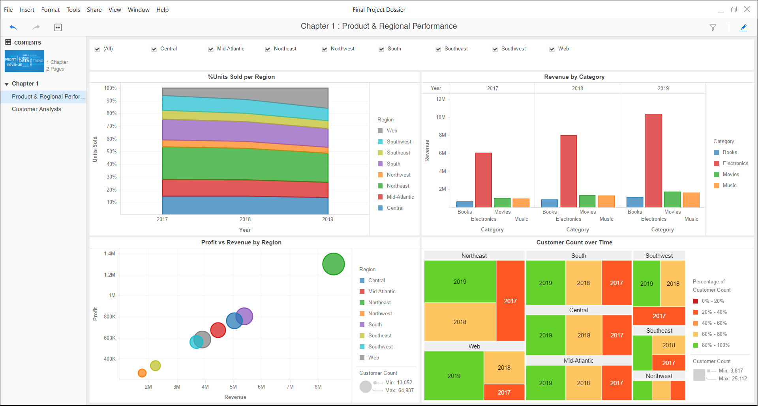

**Customer Analysis Dashboard:**

The Customer Analysis dashboard analysis the customer segment of the company. The information like revenue generated by each gender, revenue percentage contribution of different age brackets, the interest in product categories by each age bracket and the profit percentage growth in each product category by each age group is delivered. This shows us that the profit percentage growth is starting to saturate in few regions and web usage is higher in younger customers which we need to exploit through better products which are age oriented.

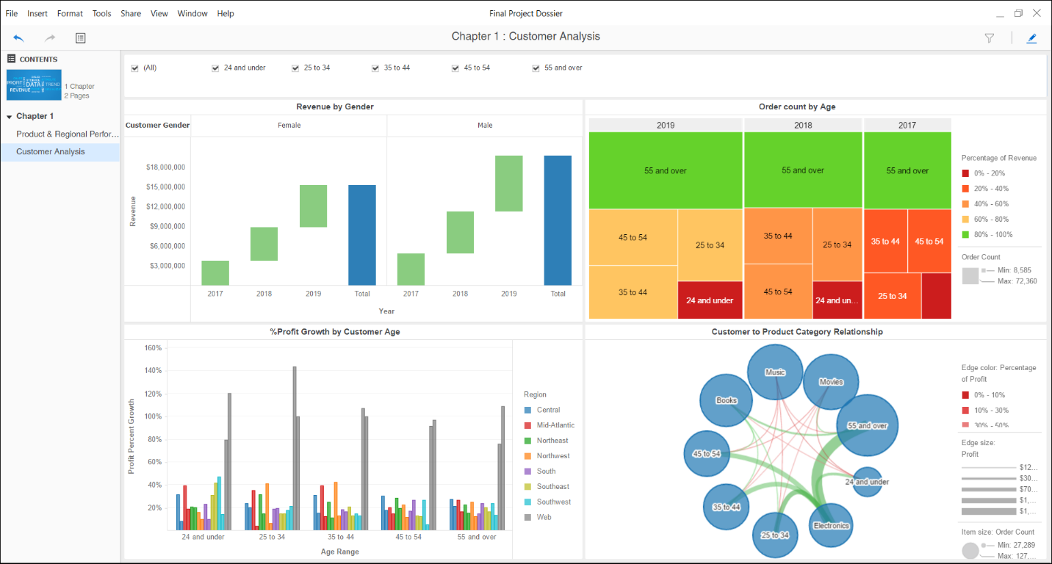

**Part VI: Single Visualization for iPad screen**

**Cash Flow Chart:**

A simple cash flow chart which considers the revenue made, costs involved, freight charges and salary expenditure. This chart derives the data from database and will change over time as the transactions are made. The CFO can use this to control the business expenditures and minimize the outgoing cash. The data is refreshed monthly and gives a view of total inflow and outflow of cash.

